**Make An LED Echo A Button**

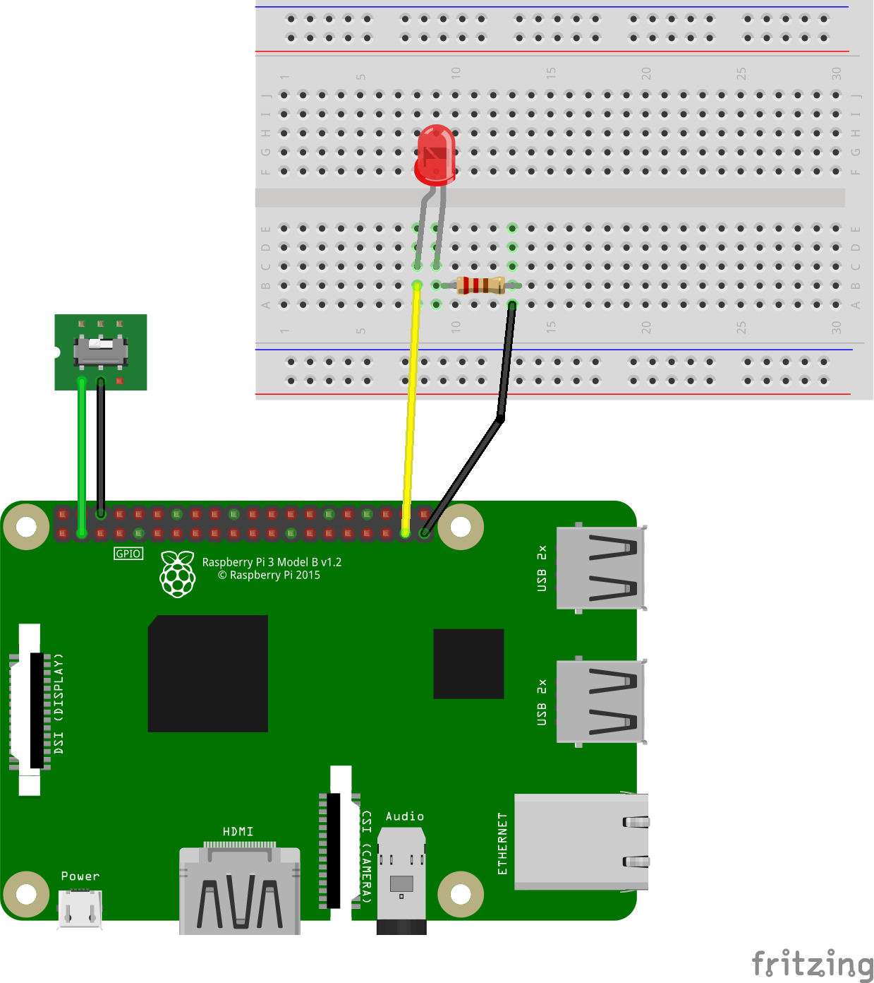

This really simple project demonstrates how to connect a button and an LED to the Raspberry Pi through the Raspberry Pi GPIO. With software, the LED turns on when the switch is flipped.

This project will give you a chance to learn three things:

1. How to connect electronics to the Raspberry Pi GPIO
2. How to control the GPIO with software
3. The difference between GPIO input and output

Ingredients

* Any Raspberry Pi
* An LED
* A switch
* A 220 ohm resistor
* A breadboard
* Jumper wires

Connections

1. Connect a green jumper wire to one side of the switch
2. Connect that green jumper wire to GPIO board pin 3 (GPIO 2)
3. Connect a black jumper wire to the other side of the switch
4. Connect that black jumper wire to GPIO board pin 6 (ground)
5. Connect a yellow wire from board pin 37 (GPIO 26)
6. Connect that yellow wire to the long leg of the LED
7. Connect one end of the 220 ohm resistor to the short leg of the LED
8. Connect a black wire to the other end of the 220 ohm resistor
9. Connect the other end of the black wire to board pin 39

Code

from gpiozero import LED, Button

from signal import pause

mySwitch = Button(2)

myLED = LED(26)

# test the connections

# myLED.blink()

myLED.source = mySwitch

pause()

***Put any notes to graphics in RED text at the bottom of the handout.***